Project Design Phase-I Problem Solution Fit

|  |  |
| --- | --- |
| Date | 08 November 2022 |
| Team ID | PNT2022TMID34253 |
| Project Name | Skill and Job Recommended |
| Maximum Marks | 2 Marks |

Step 1: Download docker from docker.com and install, it will be running the docker desktop installer.exe file

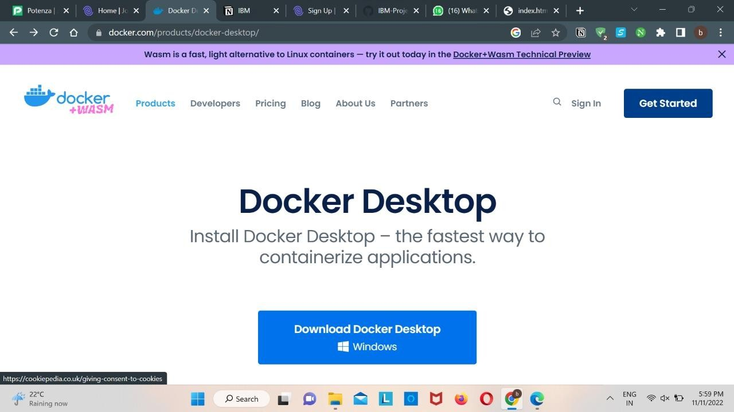

Step 2: Go to hub.docker.com register and create an account and login with the same

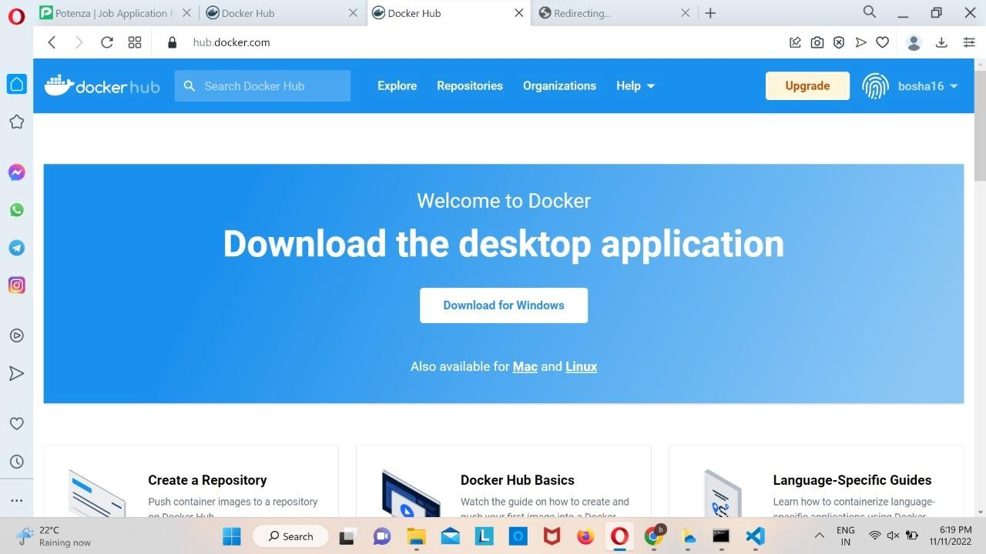

Step 3: Open Docker Desktop and start creating containers and images.

Step 4: Docker Desktop is running

